MongoDB Week-12 Task

**Create Operation:**

Q: Create a new database named "library" and switch to it.

A: use library

Q: Create a collection named "books" with fields: title, author, and published_year.

A: db.books.insertOne({title:"Letting Go", author:"David R.Hawkins", year:2000})

Q: Insert a document into the "books" collection with the details of your favorite book.

A: db.books.insertMany([{title:"PowervsForce", author:"David R.Hawkins", year:2002},{title:"Healing and Recovery", author:"David R.Hawkins", year:2003},{title:"Beyond Illusion", author:"David R.Hawkins", year:2005}])

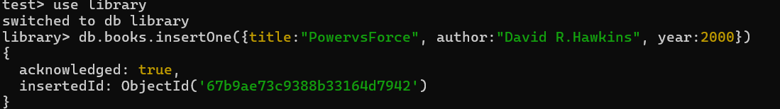

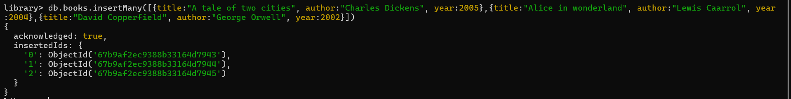

**Read Operation:**

Q: Retrieve all documents from the "books" collection.

A: db.books.find()

Q: Find and display only the documents where the author is "David R.Hawkins".

A: db.books.find({author:"David R.Hawkins"})

Q: Fetch and display the document with the earliest published year.

A: db.books.find().sort({ published_year: 1 }).limit(1)

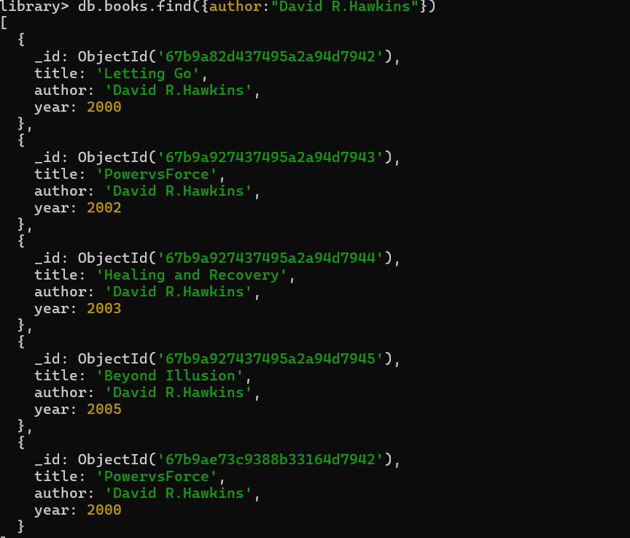

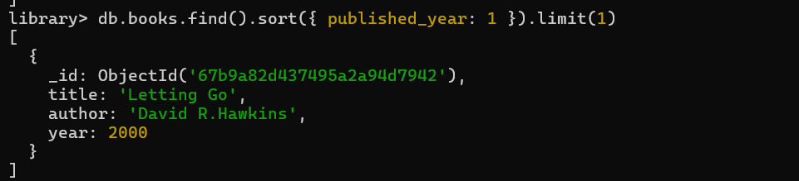

**Update Operation:**

Q: Update the published year of the book with the title "A tale of two cities" to the current year.

A: db.books.updateOne({title:"A tale of two cities"},{$set :{year:2007}})

Q: Add a new field "genre" with the value "Mystery" to all documents in the "books" collection.

A: db.books.updateMany({}, { $set: { genre: "Mystery" } })

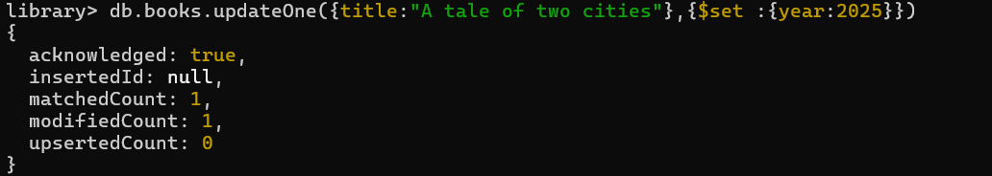

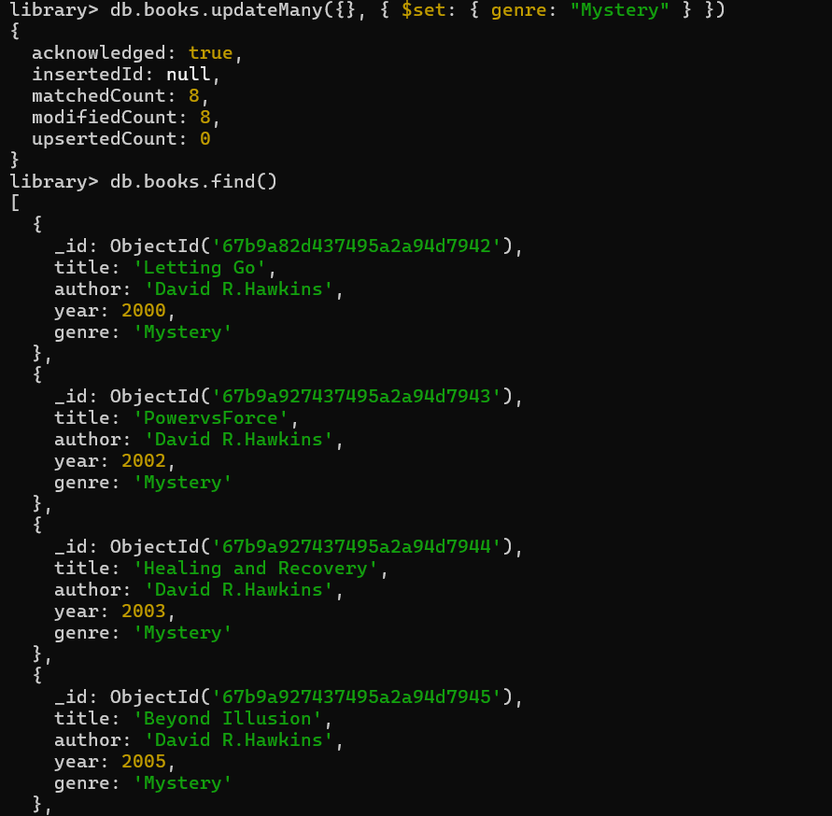

**Delete Operation:**

Q: Remove the document with the title "PowervsForce" from the "books" collection.

A: db.books.deleteOne({title:”PowervsForce”})

Q: Delete all documents from the "books" collection where the published year is before 2000.

A: db.books.deleteMany({ publishedYear: { $lt: 2000 } })

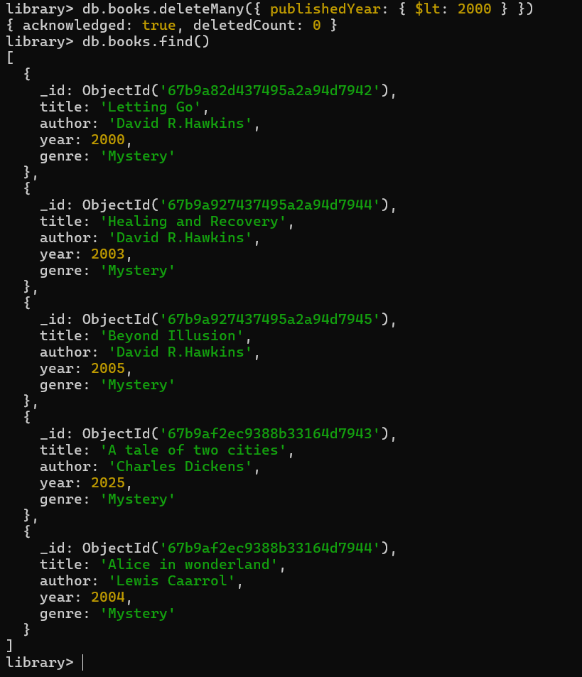

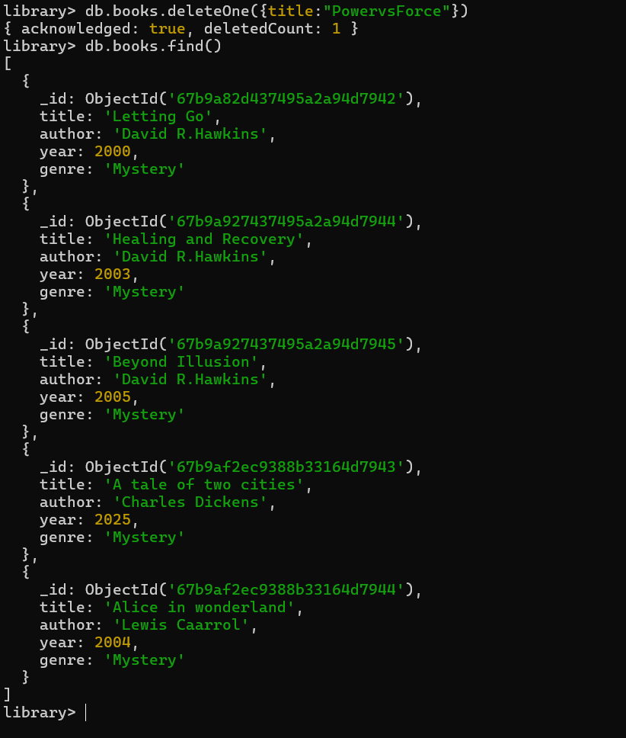

**Advanced Query:**

Q: Find and display the top 3 recently published books from the "books" collection.

A: db.books.find().sort({ year: -1 }).limit(3)

Q: Retrieve documents from the "books" collection where the title contains the word "A”

A: db.books.find({ title: { $regex: "(A)" } })

